**ASSIGNMENT-2**

**QUESTION:**

Build a python code, Assume u get temperature and humidity values (generated with a random function to a variable) and write a condition to detect an alarm in case of high temperature continuously.

**CODE:**

import random

import time

while True:

temperature = random.randint(1,100)

humidity = random.randint(1,100)

print("Temperature: ", temperature)

print("Humidity: ", humidity)

if temperature >= 60 and (30 < humidity > 60):

print("Alarm ON!")

else:

print("Alarm OFF!"

time.sleep(2)

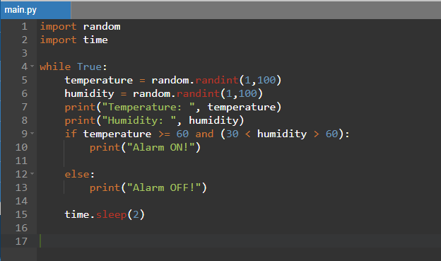

**OUTPUT:**

